**Architect**

*A Grand Design.*

Mike Croteau

www.vocebonita.xyz

**Evolution**

**does not exist!**

Each race was created.

Each race was designed. There is a purpose. **A Grand Purpose!**

Each race created independently.

**Evolution does not exist.**



Let me continue. In order to create a unique and different World, a World that could not be created with one race… each one of our cultures was created independently, each one of us created **Original in Design**.

There are distinct differences between all cultures here on Earth. Observe a few cultures some of which are neighboring and ask how did they come to be? *Let’s take a look… Throw out all preconceived notions!*

India



Germany



Saudi Arabia



Russia



Africa



Mexico



Brazil



China



We are all different.

...It is plain as day.

*There is no environmental component, weather pattern or diet that shaped us individual people over time*. *Evolution does not exist*.

In detail, observing the images on the previous pages, you can start to think about the cultures, architecture, food and lives of the people. Each are different. Start to combine the cultures and people and you have something new, something different, something unique, something that the our Grand Architect could not create with one race or culture.

**Do you understand?** Let me explain:

If one race or culture occupied the planet, all organizations of people would look the same. However, mix in some variety, more than one race and you have the possibility of cultures working together to create a unique civilization, a unique World. Like ingredients to an ultimate recipe, we, each group or race of people are designed to part of a Grand Design… an ultimate Design!

… This includes architecture, music, culinary arts, dance and movement how we interact, anything and everything, we have the possibility of creating a unique and different World, it can happen so long as every human being is allowed to live freely. Change could happen.

*Borders need to be open while remaing. Never, and I mean never do a way with pre-existing cultures, but promote while supporting collaboration and love among every culture. Invisible borders with*

*open doors...  
everywhere on Earth!*

So you want to challenge the existence of God and the idea of creationism…

**The Existence of God...** It can be proven within the definitive design in nature, and mathematics within the design. Take a look at the following image. Ask how did it come to be?



Do you see uniformity and the math within the design? You should, it’s there. There is no challenging it. If math is visible within the design, that means that there was creationism involved. No questioning it. **There is uniformity in the design of many things on our beautiful planet, including us!**

**More proof**

**that we**

**were created.**

**Lets do an exercise…**

I want you to take a look at your hand. Look at your hand from the side, do so while wiggling your fingers and move your hand back and forth.

Do this in front of a plant.



It’s important that you perform this exercise next to or in front of a plant. Spend at least 15 seconds performing this exercise, ask the following questions while performing this, “Does the hand belong, is the human hand foreign?”



The hand is foreign, the human existence is foreign, we all together everything human is foreign.

...

We did not grow or originate from Earth. We were created by an Architect, God. We did not evolve. **We were created**.

Let’s consider the single celled organism theory, that we all originated including animal life from a single celled organism, it is a harsh reality that the amount of data that would need to reside within the starting single celled organism would be very large.

*It cannot be stressed enough that* ***life on Earth would be very very strange if evolution were true****. Evolution does not exist, we did not originate from a single celled organism*, **we were all created**.

There is only so much preference data that can be stored within DNA…

**The**

**Solar System...**

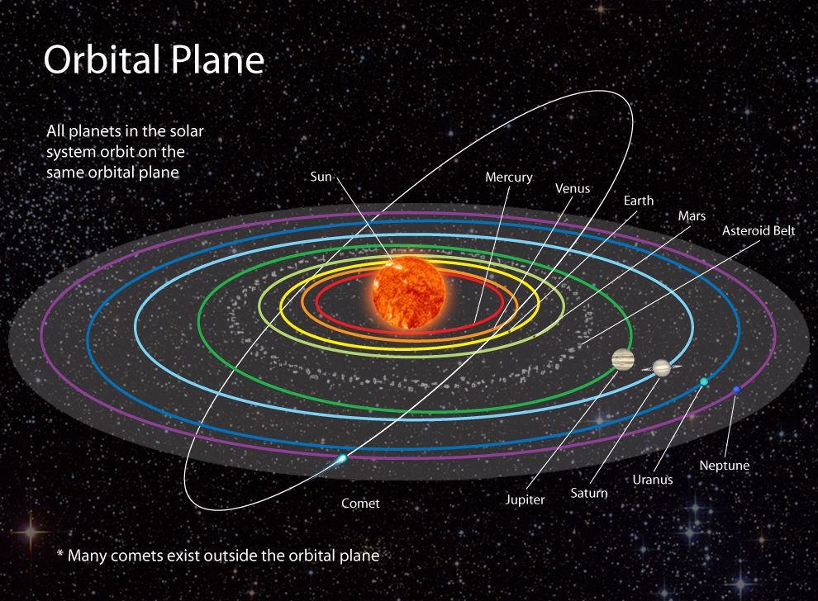

And in a short synopsis… The solar system consists of 8 planets that orbit the Sun. These planets orbit in a horizontal fashion. While orbiting these planets tilt and rotate, its systematic, uniform in design. An Architect is at play. It was created.



**DNA**

We, each culture, share similar DNA. This does not mean that we all originated from one source, one human, one race. This means DNA in fact is procedural and object oriented at the same time where blocks of code are swapped and or modified. Two cultures can share similar DNA but appear physically different.

We share DNA with plants, animals, all living life which is why the theory of evolution exists, however, evolution does not exist, it is not real.

**Again...**

Evolution does not exist. There are differences in preferences between different cultures or organizations of people. If two cultures worked together to create something, that something would turn out to be different, something new, never discovered.

A different world has an opportunity of happening.

It has an opportunity…

Open the doors to each culture… while promoting each.

**!ඔබට ස්තුතියි**

This is “Thank you!” in Sinhala, language of Sri Lanka.

Thou shall promote and foster ones culture

Thou shall support disaggregated love

...

Sweden

France



South Korea



United States



Japan

